RADIOCHROMIC FILM (RCF) TECHNOLOGY
Annexure I

Introduction: In the event of any radiological emergencies, it is imperative that affected people and first responders be quickly assessed for their radiation exposure. Radiochromic film (RCF) was developed for use as sensor elements in Instant Alert Chemical Radiation Dosimeters that are meant for rapid assessment of cumulative radiation dose received by an individual. The developed radiochromic film colour directly by absorption of radiation, and do not require any thermal, optical or chemical development. The radiation dose can be visually assessed by simply monitoring the change in colour/intensity of the sensor strip.

Salient features:
- Change in colour/colour intensity with γ- / X- radiation
- Intensity of color proportional to the radiation dose
- Near tissue equivalent
- Dose range : 10 - 500 cGy
- Energy independent (±10%) between 100 keV to 15 MV photon energies
- Dose rate independent (±10%) between 1 R/h to 1000 R/h
- Working temperature: - 20 °C to 50 °C
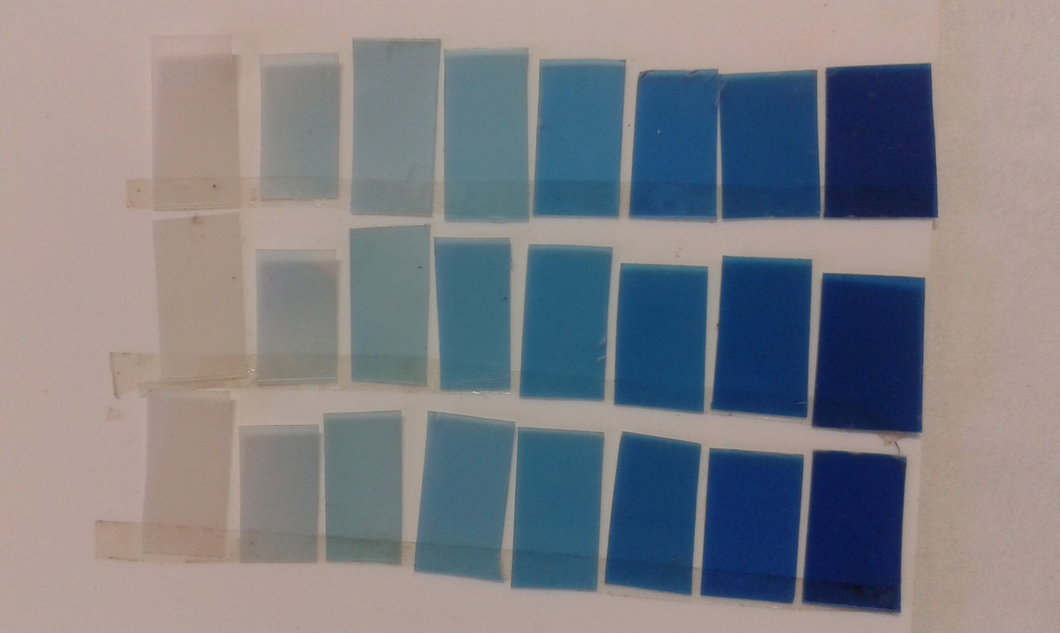

0 10 25 50 100 200 300 500 Rad
Fig. 1: DL RCF (colourless) irradiated to increasing doses of 1.25 MeV ⁶⁰Co-γ-radiation

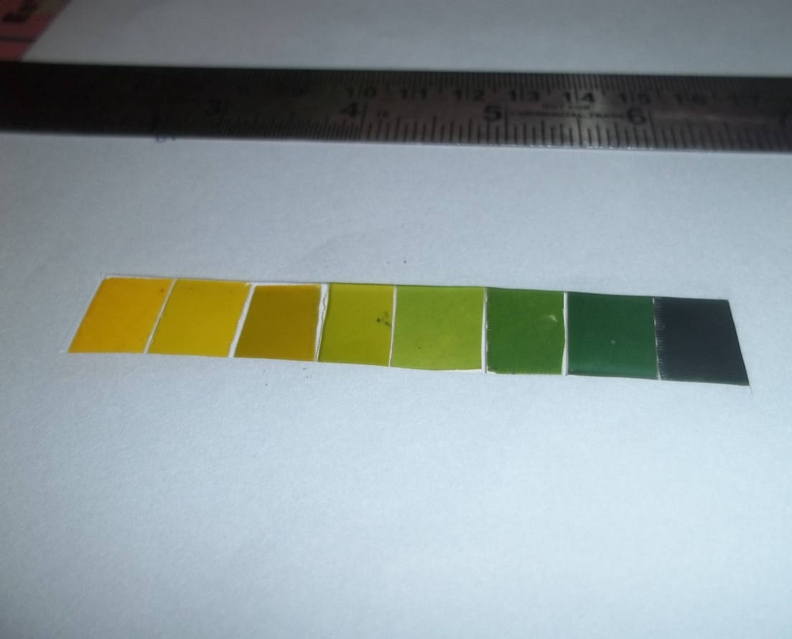

0 10 25 50 100 200 300 500 Rad
Fig.2: A DLJ developed radiochromic film (colored) irradiated to increasing doses of 10 MV X-ray

Application areas:
- Defence personnel, First responders (police, firefighters and medical personnel and National Guard), Nuclear power plant, civilian etc. as an emergency dosimeter.
- Medical dosimetry

